**Coursera Capstone Project**

**The Battle of Neighbors**

Mohamed Barghush

3/8/2020

**Introduction**

In the city of NewYork, tourists find it difficult to move around the city and find their necessary life requirements. The question is, how can we help them navigate through the city? Saying having a morning coffee is one of the necessities of a normal tourist, we need to provide tourists with a map of all the coffee shops in NewYork, so they can visit whichever they like knowing how to get to it.

Let’s also make sure the audience is explicitly defined to be the tourists that visit NewYork for a period of time and need coffee as a necessity or for the experience of trying it out in NewYork.

**Data**

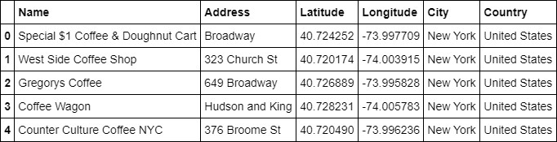A description of the data: The data used to solve this problem is a geolocation data collected from FourSquare. Adequate explanation and discussion, with examples, of the data is the following. Data is a single dataframe, containing at least a location of the coffee shops. Explanation of the location data is a standard tuple (latitude, longitude). Some other metadata like name, address and so on is also collected, but let us discuss that they are not absolutely necessary for the analysis. Example of the data used in analysis is shown below:

Table: Five first rows of data used in the machine learning algorithm.

Data will be used in the following way: by knowing the locations of already existing coffee shops, we mark them on a map of the city to show their locations.

**Methodology**

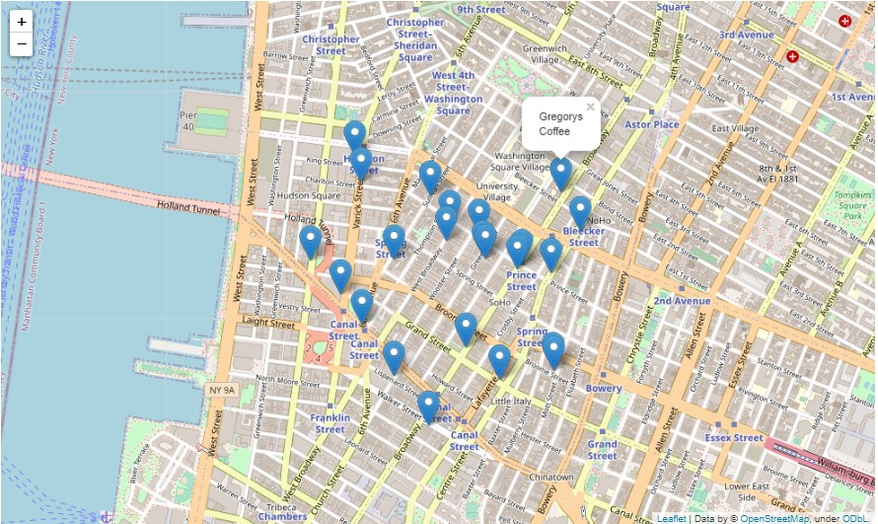A map of NewYork with marks on the locations of the coffee shops which can be clicked to show the name of the coffee shop to help find it. Map visualized using folium’s internal map function. Visualization shown below:

Figure: Data visualized to the map of NewYork.

**Discussion**

Locations of other life necessities can be marked on the map with different colors.